Google Drive

Google Drive may be used to save and share documents and files from any device or location with an internet connection. From Google Drive you may also access Google Docs and Google Sheets for editing and creating documents and spreadsheets.

Google Drive is located here: https://drive.google.com/. You may also access it by clicking on the Google Apps icon in the top right corner of Google Chrome, then on Drive.

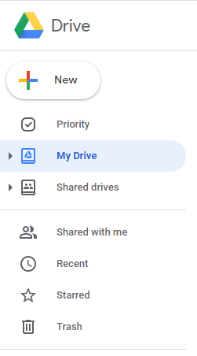Display
The folder list appears on the left side of Google Drive.
- My Drive contains the folders and files you’ve created. You are the owner of these folders and files. If you delete the folder, it’s deleted for everyone with whom you’ve shared it.
- Shared Drives are drives that are shared among a team. Anyone in the team has access to add or edit the files contained in them. If one member is removed, even if they are the original creator, the drive still exists for the remaining members.
- Shared with me contains the folders and files others have shared with you. They are owned by the sender, and may be removed by the sender. If you need to save them, you may add them to My Drive.
- Recent shows the files you’ve edited, received or saved recently.
- List View/Grid View: Toggle between List View (vertical list) or Grid View (icons) for viewing the folders and files in your Drive.
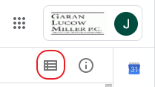

- Search Drive: Use the Search Drive box to find text in the name or content of Google Docs and Google Sheets files, and PDFs that are already searchable.

Keep your files organized into folders and subfolders. It can be difficult to find files if there are hundreds of loose files in My Drive. Files in My Drive may be sorted by Name only.

Add Files and Document to Google Drive
You can save files from your computer or email to Google Drive.
- From your computer:
  - Open the Google Drive folder or drive where you want to add your file.
  - Drag the file from your computer into Google Drive.
- 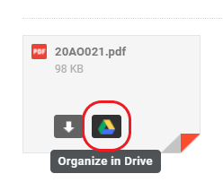From Email:
  - Hover over the email attachment
  - Click on the Save to Drive button that appears.
  - Click Organize to choose a specific Drive folder.

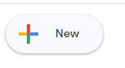Create a New Folder or Drive
- 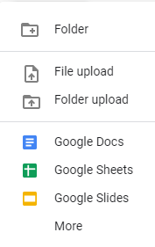To create a new folder in My Drive, click on My Drive, then the New button, then Folder.
- To create a new sub-folder, open the folder where you want to create your sub=folder, then click the New button, then Folder.
- To create a new Shared Drive, click on Shared drives, then the new button.

Google Docs
Access Google Docs:
- Direct URL: https://docs.google.com/
- From Google Chrome: Clicking on the Google Apps icon in the top right corner, then select Docs.
- From Google Drive: Create a new document or open an existing one.
Create new document:
- From My Drive: Click the New button, then Google Docs.
- From Google Docs: Click the Create New Document button in the lower right corner.
- From Open Document: Click File, New.
- Letterhead Template: To create a document based on a GLM Letterhead Template, Choose From a Template with any of the Create new document options, then choose the GLM Template you want.

Documents will be located in the folder you’re in when you created it, or by default in My Drive. To move the file to a new location, drag it from its current location to the new one.

Save and edit Existing Word Document in Google Docs:
- From Computer: Drag a Word document into Google Drive, double click it in the My Drive list to open, then click Open with Google Docs at the top.
- Email attachment: hover over the attachment, then click Edit with Google Docs.

Saving Files: Files are saved immediately, and each time you make a change. To see an earlier version of a document, click on All changes saved in Drive.

Copy a Document: Click File, then Make a copy. The new copy will be saved in the same folder.

Name a Document: The name appears above the document. Click and edit at any time.

Header & Footer: Double click in the header or footer space to edit. Click on Options to insert page numbers. To restart page numbers, add a section break to your document. (There is no formatting for alternative numbers such as i, ii, etc.)

Set Default Font and Paragraph Settings:
- For current document: Apply font and paragraph formatting you want to some text. Select the text, then click the drop-down next to Normal text and click the arrow next to Normal Text. Click Update ‘Normal text’ to match.
- 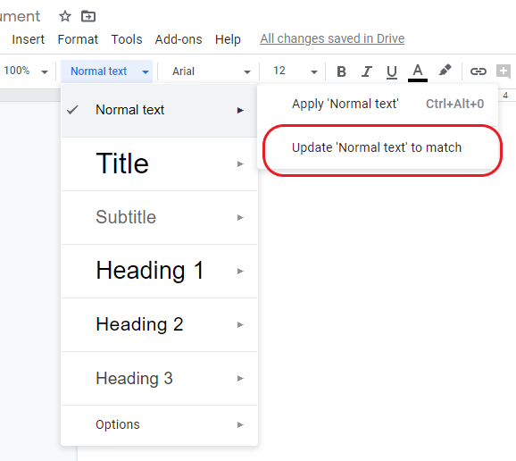For all documents: Follow the steps for Current Document, above, then click Format, Paragraph styles and then the Options gear at the bottom of the list. Click Save as my default styles.

Page Setup: Go to File, Page Setup to adjust margins, orientation and paper size.

Save as Word Document: Click File, Download, Microsoft Word. The file will be saved to your Downloads folder.

Save as PDF File: Click File, Download, PDF Document.

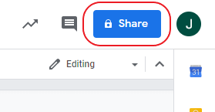Share File, Folder or Drive:
Share a file/document: With the file open, click the Share button in the top right corner. Enter the names or email addresses of the persons with whom you wish to share, then click Send. (You also have the option to notify the recipient or not, and to add a note.)

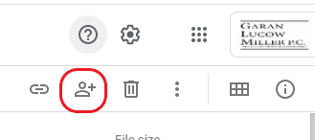Share a folder: In the My Drive view, click on the folder you wish to share so that it appears highlighted. Click the Share button on the toolbar, enter the names or email addresses of the persons with whom you wish to share, then click Send.

Share a Shared Drive: In the Shared Drives view, click to select the folder, then click the Add Members button on the toolbar.

